**Andy Spendlove**

**Elizabeth Mitchell**

**Stat 251**

**Pregnancy Related Mortality Rate in Black and White Women**

**Introduction**

The pregnancy related mortality rate (PRMR) is measured as the number of women who die from causes related to pregnancy out of every 100,000 live births. This ratio has been steadily climbing in the United States since it was first recorded in 1987. Reasons for this increase are unclear, it may just be due to increased awareness. These deaths include mothers who die from complications during pregnancy, delivery, or soon after delivery. The ratios are released, primarily in the CDC’s *Morbidity and Mortality Weekly Report.* We are interested in how this ratio compares between different demographics, if all women are dying from pregnancy related complications at the same ratio or if some groups in the population have significantly differing ratios, revealing a disadvantage. With this question in mind we chose to conduct a Bayesian analysis of the difference in PRMR between black women and white women. The parameters of interest for this analysis are the mean difference of PRMR between black and white women and the variance of the PRMR difference between black and white women.

**Methods**

*Priors*

Before collecting and analyzing data we didn’t know much about the PRMR of either white or black women. In general, we felt that per 100,000 births not many women die and that it was likely that black women died somewhat more than white women. We chose prior distributions for the means and the variations of the two groups accordingly.

For the prior distribution of the mean PRMR of black women we chose a normal distribution with a mean of 25 and variance of 100.

$μ_{Black} ∼N(25, 100)$ (See figure 1 for a plot of this distribution.)

For the prior distribution of the mean PRMR of white women we chose a normal distribution with a mean of 18 and variance of 100.

$μ_{White} ∼N(18, 100)$ (See figure 2 for a plot of this distribution.)

We used the same prior distribution for the variance of PRMR of both white women and black women, inverse gamma with a shape parameter of 2 and a rate parameter of 7.

$σ^{2}∼IG(2, 7)$ (See figure 3 for a plot of this distribution.)

*Likelihood*

We chose a normal likelihood for this data, even though it is a proportion it is such a small number out of every 100,000 live births that we decided it would be appropriate to use a normal distribution for the likelihood. This likelihood applies to the population of black women, white women as well as the difference between the two groups.

$\prod_{i = 1}^{n}{}\frac{1}{\sqrt{2πσ^{2 }}} e^{-( x_{i }- μ^{2}})^{2}/σ^{2})$

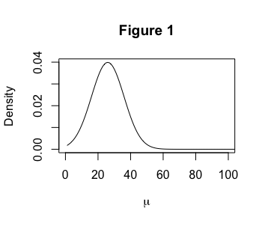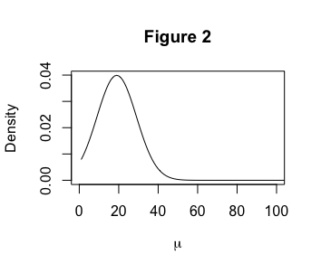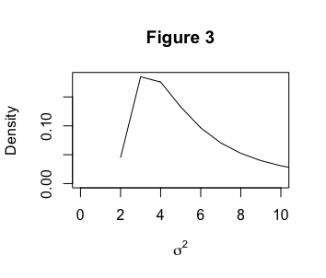

*Data*

To analyze the difference in the PRMR of black mother’s compared to white mothers we used the CDC’s reported national PRMRs for the two groups from 2007 to 2016. The CDC conducts surveillance of this information by asking all 50 states for death certificates of all women who died pregnant or within a year after pregnancy. The deaths are then classified according to cause of death. The CDC states that pregnancy related deaths are defined as “if it occurred during or within 1 year of pregnancy and was caused by a pregnancy complication, a chain of events initiated by pregnancy, or aggravation of an unrelated condition by the physiologic effects of pregnancy.”[1] Deaths determined to fit this definition are incorporated into the ratio. An initial look at the data shows that from 2007 to 2016 the mean PRMR for white women is 12.68 and the mean PRMR for black women is 40.88.

*Posterior*

Since both the population mean and population variance of the PRMR for black and white women are unknown we determined the posterior distribution with a Markov Chain Monte Carlo (MCMC) simulation using the full conditional distributions of the parameters.

Full conditional of $μ_{Black}$: µBlack |data, σ2 ∼ N(, )

Full conditional of : σ2 |data, µ ∼ IG( $γ', ϕ'$)

$γ' = γ_{B}+ \frac{n_{B}}{2}$ $ϕ' = ϕ_{B} + \frac{\sum_{i = 1}^{n}{}(x_{iB} - μ_{B})^{2}}{2}$

Full conditional of $μ_{White}$:µWhite |data, σ2 ∼ N(, )

Full conditional of ${{σ^{2}}_{White}}_{}$:

$γ' = γ_{W}+\frac{n_{W}}{2}$ $ϕ' = ϕ_{W} + \frac{\sum_{i = 1}^{n}{}(x_{iW} - μ_{W})^{2}}{2}$

With these full conditionals we were able to use Gibbs Sampling to obtain a posterior distributions for PRMR of black and white women. By subtracting the values from these distributions we found the distribution for d, the difference in means between the two populations. This approximation is shown in the attached R code. The resulting posterior distribution of the difference in Black and White appears as follows in figure 4.

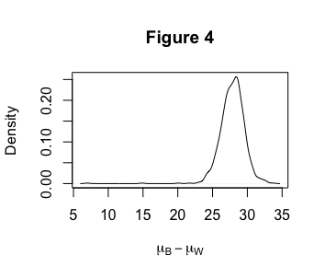

**Results**

We can see from figure 4 (the posterior distribution of the difference in mean PRMRBlack and mean PRMRWhite) that essentially all of the density was over a positive difference between the two populations, with a quite narrow spread, suggesting that the average mortality rate for black women is much higher than the average mortality rate for white women. This was confirmed as we further summarized the posterior:

The mean difference between $μ_{black}$ and $μ_{white}$ was 27.8493, with a standard deviation of 1.6263. This gives us a credible interval of (24.64715, 30.62436), meaning that there is a 95% chance that the true mean difference in PRMR for black women versus white women is between 24.64615 and 30.6244 more deaths per 100,000 live births.

We also calculated P(d > 0|data), or the probability that there is a true, population difference between black and white PRMRs given our data, and R returned a probability of 1, meaning that there is virtually a 100% chance that there is a real difference in the population, given our data.

**Conclusion**

We set out with this analysis to answer the question, “How do maternal mortality rates differ between demographics, if at all?” The findings from this analysis are quite stark: According to this data obtained from the CDC, during the timeframe of 2007 to 2016, a significant and startlingly higher ratio of black women suffered pregnancy-related deaths than white women, about 28 more per 100,000 live births. Our prior belief was that there was probably some disparity between these demographics, with black women suffering pregnancy-related deaths somewhat more often, and our posterior findings confirmed this; in fact, the disparity turned out to be much greater than we had assumed a priori.

One limitation in this analysis is that our data set was fairly small, with only five data points per demographic. Each of these data points is a mean PRMR representing dozens of individual observations that the CDC obtained directly from hospitals over a given period of time, so there are a lot more than just five individual observations. But still, having access to even more data than just these five mean PRMRs per demographic could provide more universally definitive results.

Every maternal death is a tragedy, and the fact that the average PRMR for all U.S. women is 16.7, in spite of our nation’s medical advances, is cause for concern. But according to our analysis and the consensus among the medical community, this problem severely and disproportionately affects black women. Further research into the societal, institutional, and perhaps genetic causes of this disparity must be pursued to ensure that black mothers are given every opportunity to live and to be there for their children.

Appendix:

**library**(invgamma)

x <- seq(0, 1000, length = 1000)

*#prior values for PRMR of Black Mothers*

*# mu ~ N(lambda, tau2)*

lambda.b <- 25

tau2.b <- 100

*# sigma2 ~ IG(gamma, phi)*

gamma.b <- 2

phi.b <- 7

plot(dnorm(x, lambda.b, sqrt(tau2.b)), xlim = c(0, 100), main = "Figure 1", ylab = "Density", xlab=expression(mu), type = "l")

plot(dinvgamma(x, gamma.b, phi.b), xlim = c(0, 10),main = "Figure 3", ylab = "Density", xlab=expression(sigma^2), type = "l")

*#prior values for PRMR of White Mothers*

*# mu ~ N(lambda, tau2)*

lambda.w <- 18

tau2.w <- 100

*# sigma2 ~ IG(gamma, phi)*

gamma.w <- 2

phi.w <- 7

plot(dnorm(x, lambda.w, sqrt(tau2.w)), xlim = c(0, 100), main = "Figure 2", ylab = "Density", xlab=expression(mu), type = "l")

plot(dinvgamma(x, gamma.w, phi.w), xlim = c(0, 10), main = "Figure 4", ylab = "Density", xlab = expression(sigma^2), type = "l")

PRMR.b <- c(35.6, 41.6, 44.3, 42.1, 40.8)

PRMR.w <- c(11.5, 12.8, 12.4, 13.5, 13.2)

*#initial values for mu and sigma2*

mu.b <- 25

sigma2.b <- 100

*#initial values for mu and sigma2*

mu.w <- 18

sigma2.w <- 100

*#create vectors to save the drawn values*

n.ITERS <- 1000

mu.save.b <- rep(0, n.ITERS)

sigma2.save.b <- rep(0, n.ITERS)

mu.save.b[1] <- mu.b

sigma2.save.b[1] <- sigma2.b

**for**(i **in** 2:n.ITERS){

*#Sample mu*

mu.post.mean.b <- (tau2.b*sum(PRMR.b) + sigma2.b*lambda.b)/(length(PRMR.b)*tau2.b + sigma2.b)

mu.post.sd.b <- sqrt((tau2.b*sigma2.b)/(length(PRMR.b)*tau2.b + sigma2.b))

mu.b <- rnorm(1, mu.post.mean.b, mu.post.sd.b)

mu.save.b[i] <- mu.b

*#Sample sigma2*

sigma2.post.gamma.b <- length(PRMR.b)/2 + gamma.b

sigma2.post.phi.b <- phi.b + .5*sum((PRMR.b - mu.b)^2)

sigma2.b <- 1/rgamma(1, sigma2.post.gamma.b, sigma2.post.phi.b)

sigma2.save.b[i] <- sigma2.b

}

plot(density(sigma2.save.b), main = "Figure 5", xlab = expression(sigma^2))

plot(density(mu.save.b), main = "Figure 4", xlab = expression(mu))

*#initial values for mu and sigma2*

mu.w <- 25

sigma2.w <- 100

*#initial values for mu and sigma2*

mu.w <- 18

sigma2.w <- 100

*#create vectors to save the drawn values*

n.ITERS <- 1000

mu.save.w <- rep(0, n.ITERS)

sigma2.save.w <- rep(0, n.ITERS)

mu.save.w[1] <- mu.w

sigma2.save.w[1] <- sigma2.w

**for**(i **in** 2:n.ITERS){

*#Sample mu*

mu.post.mean.w <- (tau2.w*sum(PRMR.w) + sigma2.w*lambda.w)/(length(PRMR.w)*tau2.w + sigma2.w)

mu.post.sd.w <- sqrt((tau2.w*sigma2.w)/(length(PRMR.w)*tau2.w + sigma2.w))

mu.w <- rnorm(1, mu.post.mean.w, mu.post.sd.w)

mu.save.w[i] <- mu.w

*#Sample sigma2*

sigma2.post.gamma.w <- length(PRMR.w)/2 + gamma.w

sigma2.post.phi.w <- phi.w + .5*sum((PRMR.w - mu.w)^2)

sigma2.w <- 1/rgamma(1, sigma2.post.gamma.w, sigma2.post.phi.w)

sigma2.save.w[i] <- sigma2.w

}

plot(density(sigma2.save.w), main = "Figure 7", xlab = expression(sigma^2))

plot(density(mu.save.w), main = "Figure 6", xlab = expression(mu))

difference <- mu.save.b - mu.save.w

plot(density(difference), xlab=expression(mu[B] - mu[W]), ylab="Density", main="Figure 4")

mean(difference > 0)

quantile(difference, c(.025, .975))

mean(difference)

var(difference)

1. https://www.cdc.gov/mmwr/volumes/68/wr/mm6835a3.htm